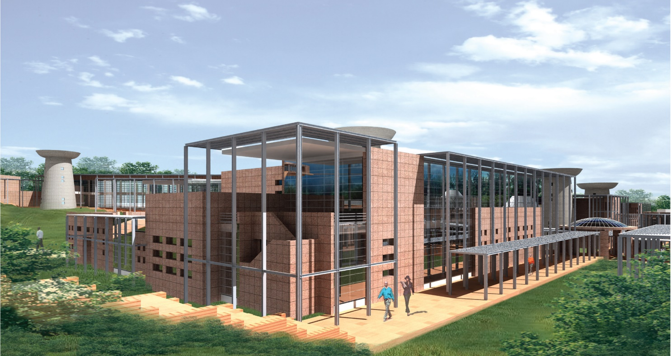
LIBRARY, ARCHIVES & DESTRUCTION CENTRE – D&R
South East View for Library, Archives & Destruction Centre – D & R

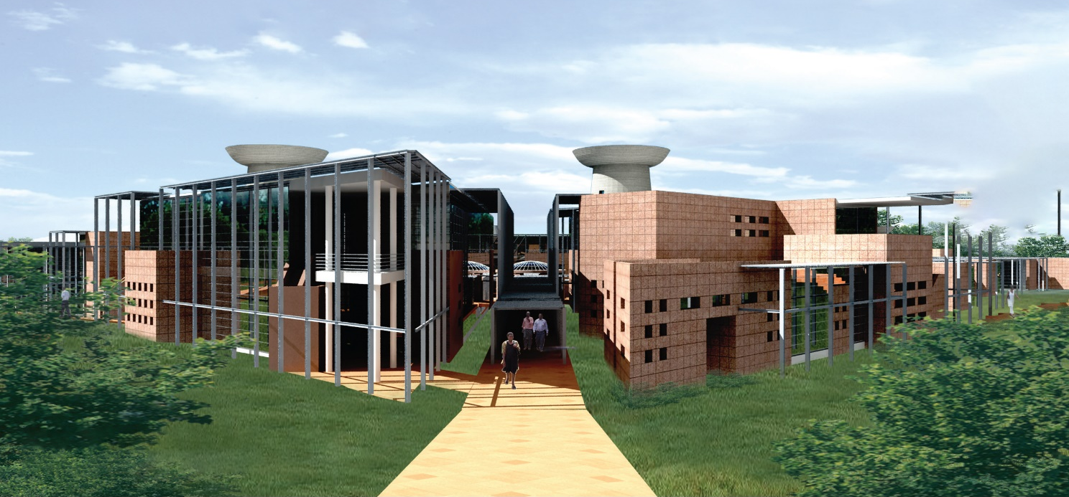
South West View for Library, Archives & Destruction Centre – D & R

General Description: The proposed ‘Library & Archives – D&R’ Building has been designed as the research hub of RMMTA. This building is the center of research as it houses the most important space – the library and the archives for students. The other archival facilities such as record room, audio – visual room, reference room etc. are provided in this building. Incinerator room with different access is also housed in this block.
Masterplan Location & Site: The proposed building “Library, Archives & Destruction Centre” has been planned at the junction of faculty buildings. This strategic location at the turning point in the masterplan is apt for a library to be placed as the users’ travel distance is reduced.
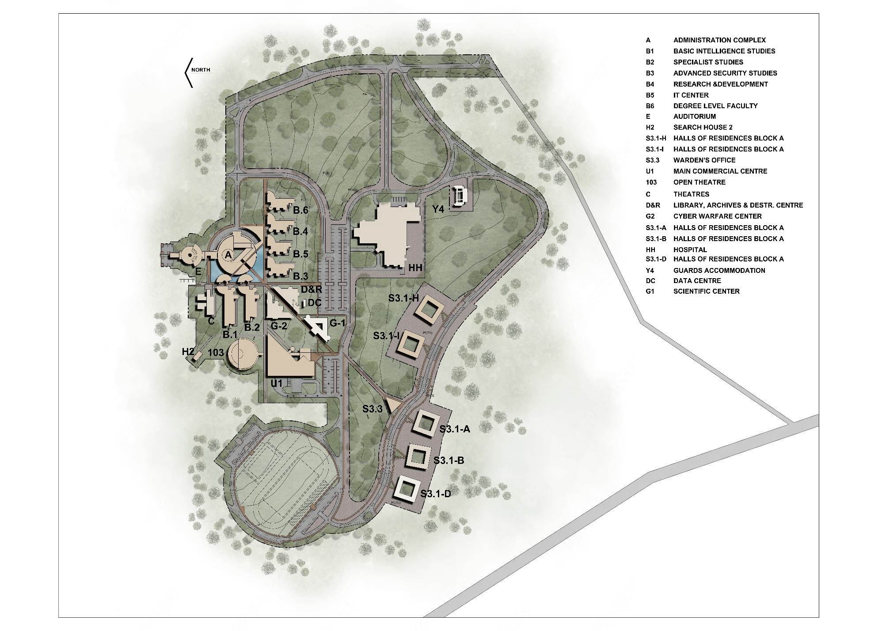

Design Objectives:
- Provide reading space for students
- House the archives in the same building for ease of the user
Design Concept:
The concept was to design a space dedicated to referral work. Alumni past experiences and learning are to well preserved and should be available for others for learning. The archives are of different types. Dedicated rooms with separate reading area for library will help the user to have research related facilities under one roof.
Building Codes:
The Campus has been designed complying with following codes for the projectL
1. City of Harare Design Manual, Ministry of Local Government Manual.
2. The International Building Code (IBC) - 2003
3. National Fire Protection Act - NFPA Fire code (12th Edition)
4. International Plumbing Code-IPC-2009
(* Need to be confirmed by Client)

Floor wise Configuration:
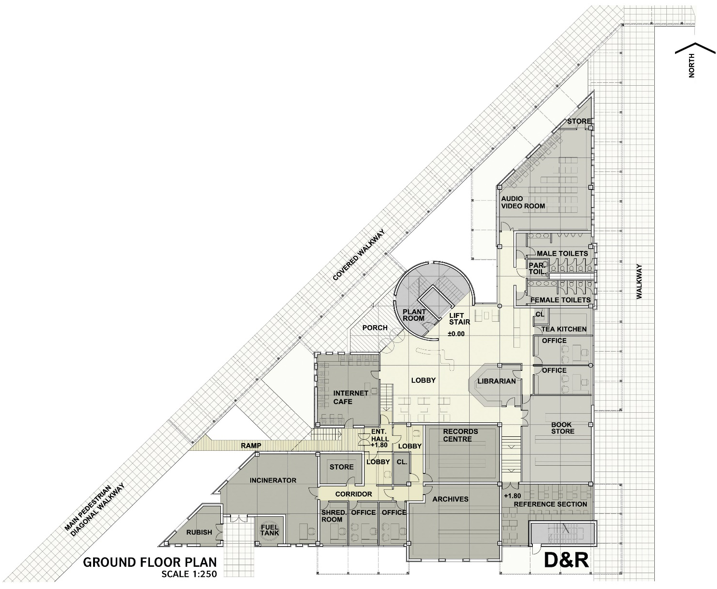
Ground Floor Plan: The Ground floor comprises of archives along with facilities such as audio-visual room, book store, records center, reference center, offices for managing staff, internet café, librarian cabin, incinerator and utility areas. The library and reading area is provided on the upper level. The covered walkway opens into lobby area and conical architectural element with vertical transportation. The triangular shape of the plan is taken up by the interior spaces. The rooms are perpendicular to each other just further segregating the rooms for ease of the user.
Ground floor plan for Library, Archives & Destruction Centre – D & R

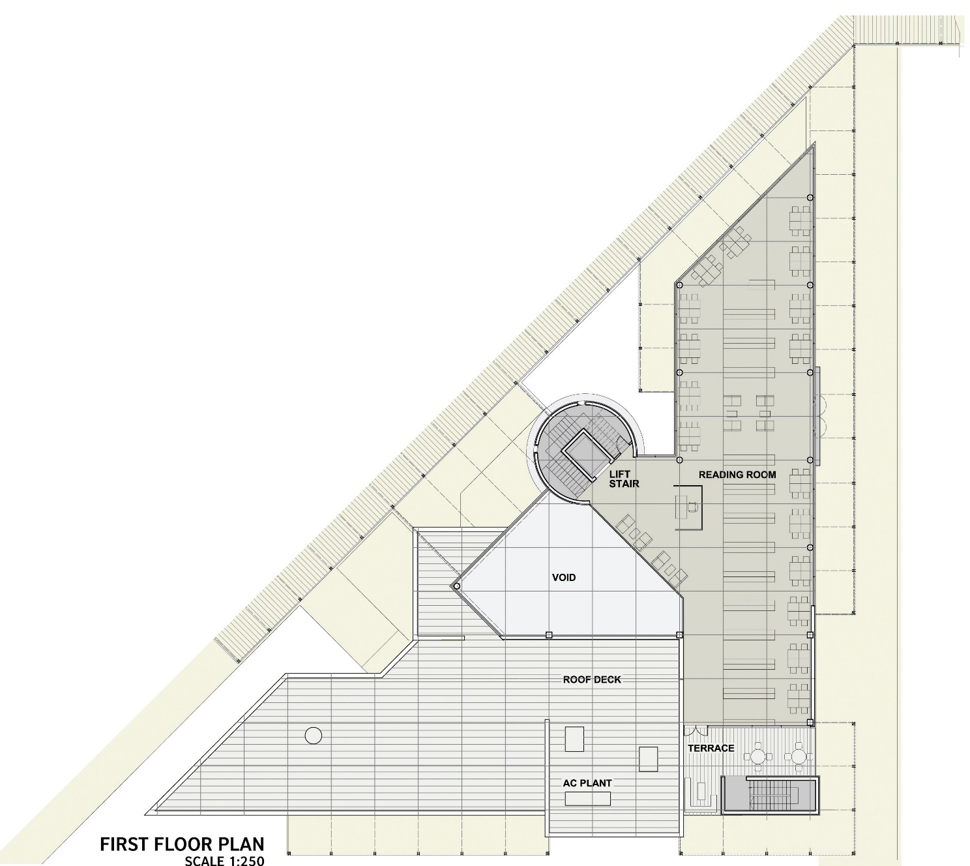
First Floor Plan: The First floor comprises of reading room, a small breakout terrace, plant room. Well equipped library with all necessary infrastructure is segregated and provided at the upper level for the students to have peaceful environment while reading.

First floor plan for Library, Archives & Destruction Centre – D & R

Area Statement: The area statement for the building is as mentioned in the Table below. The Gross floor areas-GFA/ or the overall Built-Up Area-BUA of “Library, Archives & Destruction Centre” is 2035 Sqm
Fire safety Norms:
General Note:
The entire fire safety installation shall be compliance with the Local Authority Codes and Building Regulations, and when not available, International Equivalent Standards for the entire complex to ensure the highest safety standard and uniformity of system. Further, before property is opened to public, the protection shall be fully operated and tested under simulated conditions demonstrate compliance with the most stringent standards, codes and guidelines.
The following points have been considered, as per the building codes, for ensuring fire and life safety:
- Type of Construction
As per IB 2003, construction of the building has been categorized as type I-B
- Staircase.
All the staircases have been provided with a width of 1.5 mts which is as per the International Standards. They also satisfy the requirements of International Standards.
Egress enclosures shall have a fire rating of 2 hrs
- Exit travel distances
Staircase locations are planned to achieve the travel distance within 30m, based on International Standards.
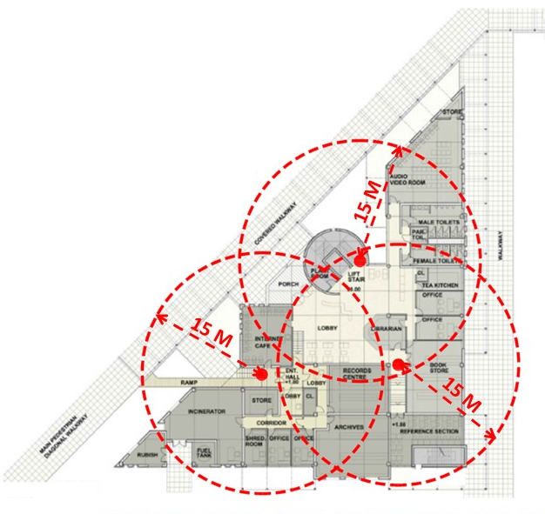
Exit travel distance for Library, Archives & Destruction Centre

Occupancy And Sanitary Calculations: The building comprises of Classrooms, Lecturer Rooms, Meeting Rooms, and support spaces with toilet spaces (Male & Female) on each floor.

Elevator Calculations: There is Lift (located at entrance of building) provision made to facilitate vertical circulation

Building Finishes (Exterior):
- Façade
  - Cement/sand plaster with wood float finish
  - Synthetic Plaster
  - External quality PVA paint
- Doors
  - Custom made standard gauge pressed metal door frame, 2mm thick
  - 44 mm internal quality semi-solid core flush panel door with commercial veneer and hardwood edging
  - Double Equal Shutter Door with metal frame with louver on top
  - Double Unequal Shutter Door with metal frame
  - Single Shutter Full Louvered Door with metal frame
  - Aluminum Door Frame with Glass
  - Roiling Shutter

- Glazing/ Windows Types
  - Aluminum Windows with 6mm Sun Reflecting Single Glazing
  - Aluminum Windows with Louvers
  - Aluminum Windows with 4mm Clear Float Glass top Openable

- Roof
  - 40mm thick layer of crushed stone (gravel)
  - Pre-painted IBR metal roof sheet

- Railings
  - Stainless Steel tube handrail
  - Mild Steel Railing with Paint finish
Building Finishes (Interior):
- Walls
  - Internal quality PVA paint
  - Vitrified tile cladding
  - Glazed ceramic tiles
  - 75mm high cement / sand skirting
  - Vitrified tile Skirting
  - 108 X 19mm (Including 19 X 19mm quadrant) hardwood Skirting

- Floor
  - External grade Anti-skid Vitrified tiles
  - Vitrified tiles
  - Ceramic tiles, non-slip surface
  - Granite Tread & Riser
  - Heavy duty contract Bitumen backed carpet tile

- Ceiling
  - Perforated gypsum board
  - Plain gypsum board
  - Internal quality PVA paint
  - Pre-painted and preform aluminum linear ceiling

- Special Item
  - Covered Walkways & Canopy - MS steel with external quality enamel paint

Buildings Illustrations – Views, Plans, Sections, elevations
Note: Refer separate annexure for drawings attached
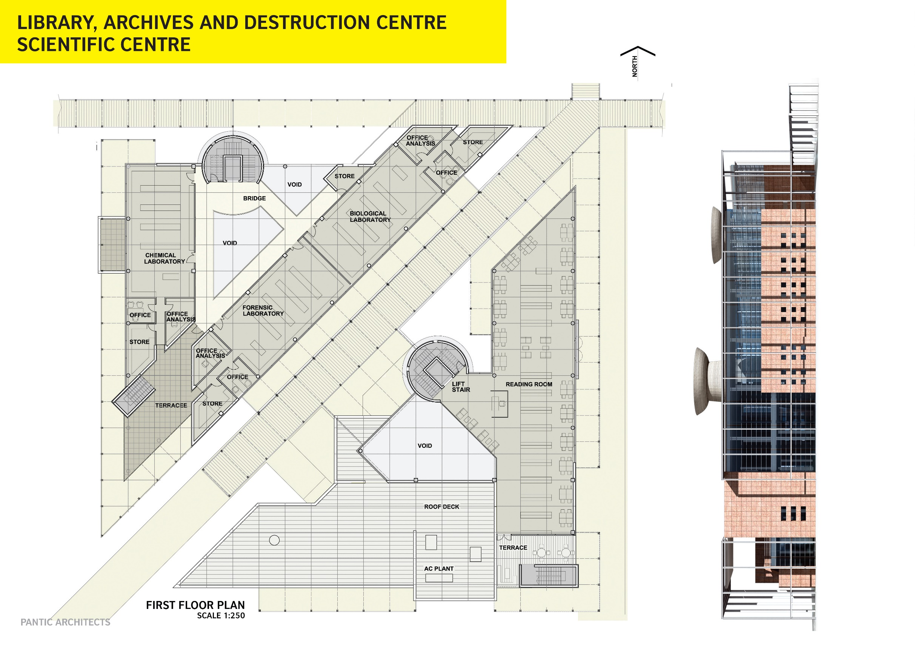
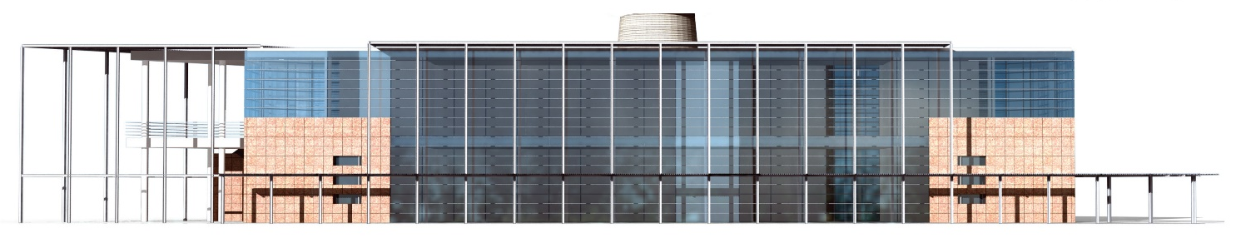
Elevations:
SOUTH EAST ELEVATION
EAST ELEVATION
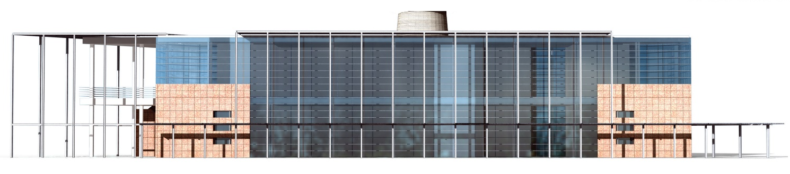
NORTH EAST ELEVATION

Construction on site (Current status): This block is not yet constructed on site.

Schedule of Finishes:
FIRST FLOOR
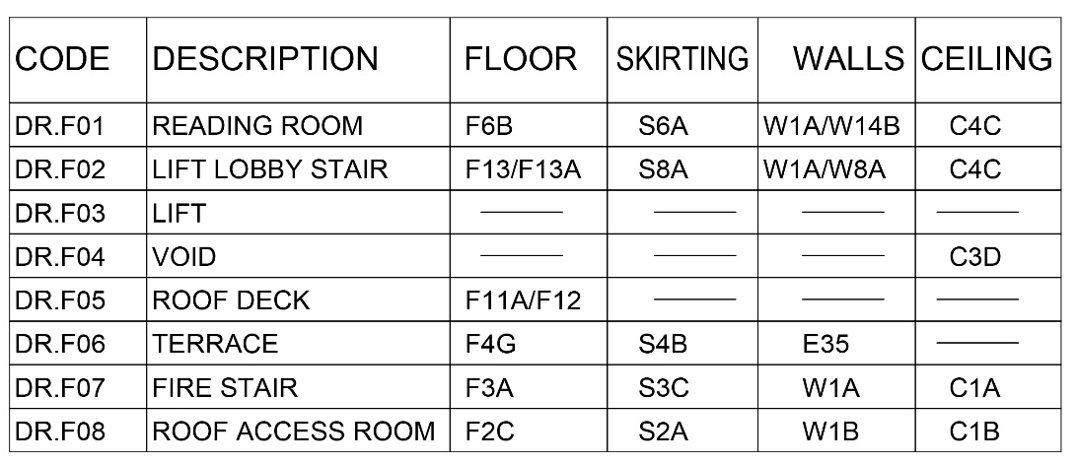

Note: For Finishes code specifications / details refer separate Annexure-I attached
Note:
- Refer separate Annexure for Schedule of finishes
- Refer separate Annexure for MEP DBR Report
- Refer separate Annexure for Structure DBR Report

